Massive section about the flaws of CCL management and IR report.

Section about revenues and pricing general market

* 2022Q3/Q4 had fleet operation back to nearly 100%.
* EBITDA are starting to become positive again
* Ticket prices and Extras section
  + Looking purely at PCD efficiency, CCL manages to squeeze more in onboard extras, however suffers in ticket pricing.
* Advanced ticket sales (NCLH earnings report) seem to indicate that revenues will return to higher levels than 2019, at least briefly
* Occupancy rate is returning to 100% and great levels

Debt and leverage

* These are highly levered companies, by any metric these companies look absolutely degenerate
* Key point of interest in the interest coverage ratio
* Cash balance

Booking experience

* Table
* Ads
* Included
* Cost

Cross examination

* Big table MRQ
* 3 way comparison
* Why is NCLH performing so well and could be the easy short term play
* Why is CCL performing so poorly
* By flying the flags of certain countries they can avoid high taxes (USA is ~20%, CCL is the highest tax payer and is only about 4%), use cheaper foreign labor, avoid difficult country regulations (and thus costly lawsuits).
* Flags on convenience, on international waters, the flag of the ship is the country you are on.
* Because of USA passengers make up the majority of the passengers, the cruise liner can reduce labor costs even further by using 'tipping culture' just like a restaurant (and also avoid paying more labor costs through taxation and workers comp)
* Tipping.
* And just a note on taxes: RCL made a net income before taxes of $1,908 million in 2019, they paid all of $8 million, in taxes, that is a tax rate of 0.4%! And the year before it was 0.4%, before that 0.1%, and before that was 0.2%!! These are billion-dollar incomes and they don’t even pay a penny on the dollar in tax.
* The primary customer basis are vacationers and retirees, this client base typically has lots of money to spend.
* Using the economies of scale, cruise liners have gone up to insane sizes. The Wonder of the Seas, owned by RCL, can host nearly 7000 passengers.
* At this scale, most of the costs for mega ships can almost be modeled as fixed: fuel usage is nearly fixed per route, payrolls to run the ship would be fixed, costs for onboard entertainment would be fixed, ship depreciation/amortization is fixed (assuming linear decay). The only regular variable cost I can think of is food to feed passengers; and at the scale of a mega ship, they probably make this fixed too and just throw out the stuff they don’t use to avoid logistical costs.
* Unlike traditional resorts and luxury hotels, a cruise ship doesn't need any land and is a depreciating asset giving it an accounting benefit over land, which is either leased or non-depreciable.
* How does the Cruise liner make money?
  + After taxes and fees: A room on Carnival for a 13 day trip is $1835.04 (Figure 1)
  + After taxes and fees: A room at Downtown Grand (a cheaper vegas resort) for 13 nights is $1801.22 (Figure 2)
  + And the cruise provides all meals any time of the day and onboard entertainment for free! Not to mention the travel to different countries to boot.
  + A cruise ship is a luxury resort on the damn water and you’re telling me that it’s CHEAPER than a basic hotel on land? Yup.
  + Using the 2019 numbers of CCL, the passenger ticket is sold at a 24.4% LOSS. That is a WSB style degenerate loss. And this is from a supposedly ‘wealthy/spendy’ customer basis. What the hell are they thinking!?
  + Cruise liners make money the same way as the ‘free’ phone apps like Candy Crush and Raid Shadow Legends do. All they have to do is get you on the ship; and once you’re there, all the premium unlocks are waiting around for you, fancier cuisine, alcoholic beverages, premium entertainment (you nasty, think broadway shows, opera, orchestras, go-karting, airtunnel simulated sky diving), spas, massages, gift shops, the casino, and a million other onboard extras. This is where the cruise liners cash in.
  + And as we all know, people on vacation are very stupid and will spend on the dumbest things when given the chance. So, the cheap cost of ticket is a loss leader to fill the rooms so they can attract more people with poor spending habits and boost revenue.
* Here’s the reasons why you shouldn’t buy and consider shorting a cruise liner:
  + The loss leader business model (is highly regarded) means that people will take advantage of the cheap luxury and when that catches on with the greater public there will be actual losses.
  + Once governments begin to crack down on taxation, the cruise liners are one of the industries that would be hit the hardest. Eg. the cringe global minimum corporate tax treaty, so that the governments can continue to milk the general populus dry by funneling even more money up to the govt so they can piss it down the drain ditch where the quants from Wall Street gather, bathe, and drink from thus further increasing the vast wealth disparity, even though every politician says they’re against doing that exact thing; or maybe the governments will end world hunger with it, I dunno, I’m regarded. Anyway, if implemented quickly this would be very bad as the cruise liners would be hit the hardest. (Or maybe it's the casinos, I’m too regarded to analyze those things)
  + The debt load of all of these is insane (as highly regarded as we are)! NCLH has a leverage (debt/equity) ratio of 3662.93! That’s more than our friend Billy Hwang, and he’s in jail now! And with the interest rates they are paying, they have no chance, that maintenance call is just around the corner.
  + COVID-19 took these guys out completely, they made ZERO revenue for TWO WHOLE YEARS!!! When the next guy starts eating wild cone worms and URMOM-23 shows up, these guys are dead (be sure to post losses for the squad when this happens)
  + The world is going GREEN, these guys are gonna get gutted (If the world is so green, why is my portfolio so red?). Burning dead animals from a bazillion years ago is like so 2010, gosh, btw I’m a vegan and organic free range only, and I’m like mentally ill in like 6 different ways!
  + There are too few potential passengers for all of these giants in the space. They are going to cannibalize each other with that loss leading model just like the automotive space did in the early 2000’s and then be left with giant money burning ships and billions in debt. NCLH is already planning to expanding its fleet by 24% (+9 ships) by 2027.
  + When the hard landing comes and a global recession hits, that is going to reduce the consumer spending on luxuries and vacations by a lot, this would kill cruise liners
* Why should you buy a cruise liner?
  + This is a very fast expanding industry
  + The loss leader business model is very good for growth and once growth stops and the cruise-bugs have been recruited, the business model can pivot and increase ticket prices to make up for loss of growth.
  + There is a pent up demand for travel
  + The travel, hospitality, and services industry is already in a deep hole, how much lower can it dig (post losses for the lads when it goes to zero)
  + COVID-19 restrictions have been effectively eliminated in 2023, this means the travel and leisure industry can return to normal growth trends.
  + The global minimum tax treaty won’t be implemented in forever, so there are many years of good cashflow left.
  + Cruise liners are an inexpensive vacation and could hold up OK in a soft landing / low growth environment where people still want to enjoy luxuries.
  + Cruise liners would do very well in a high growth environment where people are employed and have money to spend.

Comparison table

Debt load, leverage (debt/equity ratio), run rate, cash extraction per passenger, market/passnger growth trend, revenues, margins,

Booking experience

NCLH definitely has the best booking experience, their pricing is actually true to their word

Possible operational improvements

* Advertise the free food, drink, etc.
  + NCLH paradigm shift
  + NCLH commands higher ticket prices, not because they do anything better, but because they tell the customers what they get in a simple easy to access manner
* Advertise the 3rd/4th person or kid discounts
  + Room efficiency (Extras per APCD) increases slightly because of family spending on premium extras
* Studio rooms
  + Not particularly good for room efficiency, but increases ticket sales
  + Depends on how you view individual riders, are they looking for a cheap vacation for 1. Or are they big spenders?
  + Evidence points to them being big spenders (Extras per APCD, and Ticket per APCD). Even so, the studio rooms may artificially inflate the Extras per APCD, and Ticket per APCD metric as the sqft requirement per passenger per room type is surely higher than other room variants.

Improvements

* If a metric of Revenue per passenger per day per sqft, or simply APCD per sqft, were to be calculated, it could show the true value of the studio rooms.
$\frac{Revenue}{\frac{Standard passenger count in a cabin}{cabin}*Number of cabins *Operating cruise days*\frac{Avg sqft of cabins}{cabin}*Number of cabins}$

$\frac{Revenue}{Passenger capacity*Operating cruise days*Sqft of all cabins}$

* A metric of sqft/passenger capacity would also be a good metric to have
* Management evaluation
* Capital investments/expenditures

Image 1:

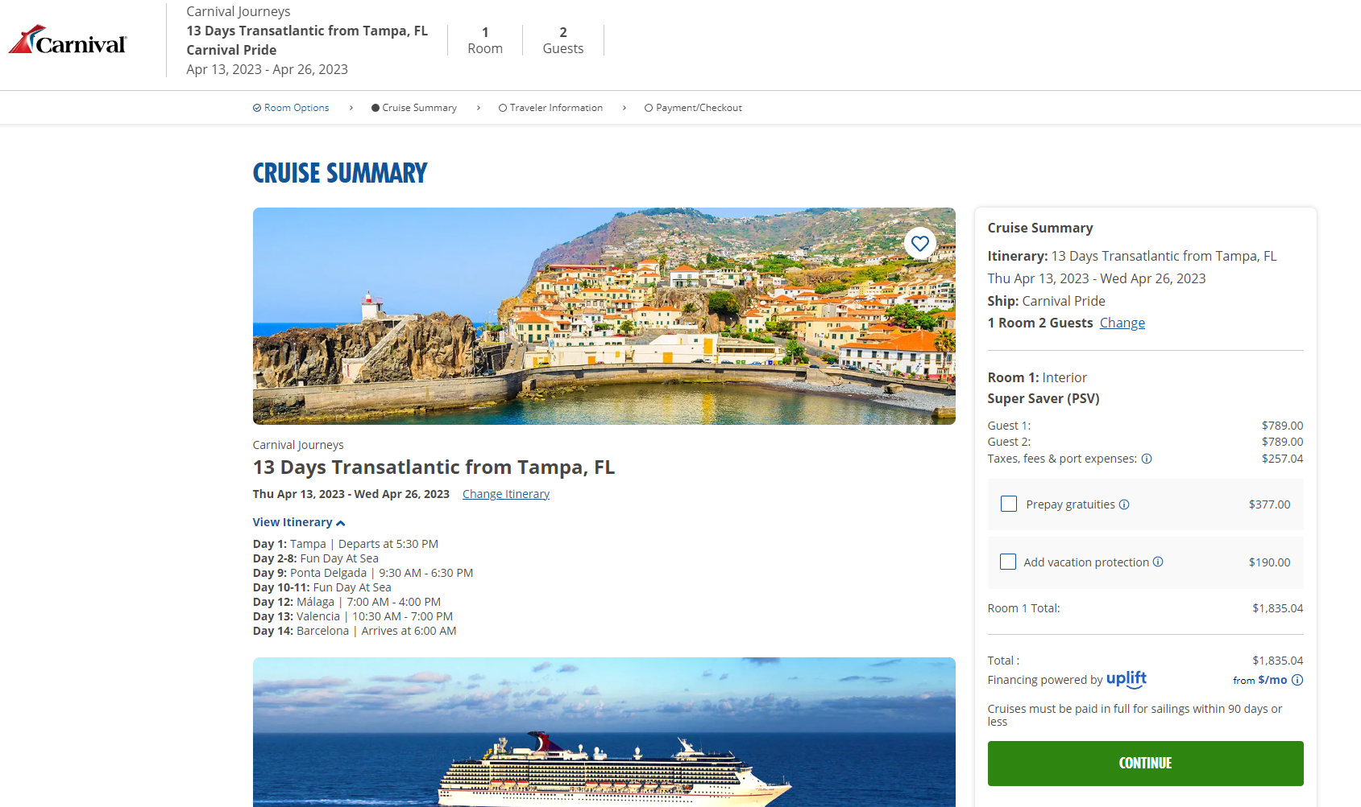

Image 2:

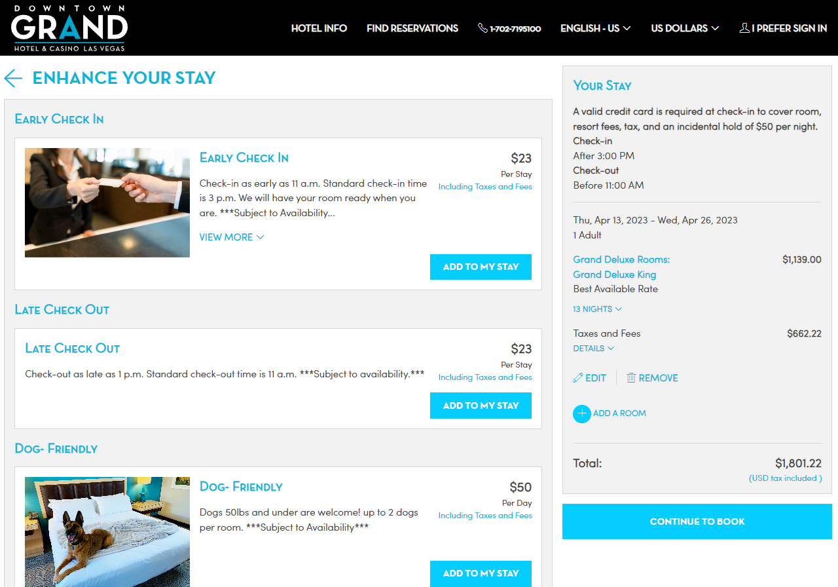

Graph of ticket sales to onboard revenue

Graph of cruise passenger volume

Graph of debt load

Graph of debt/equity

Booking experience

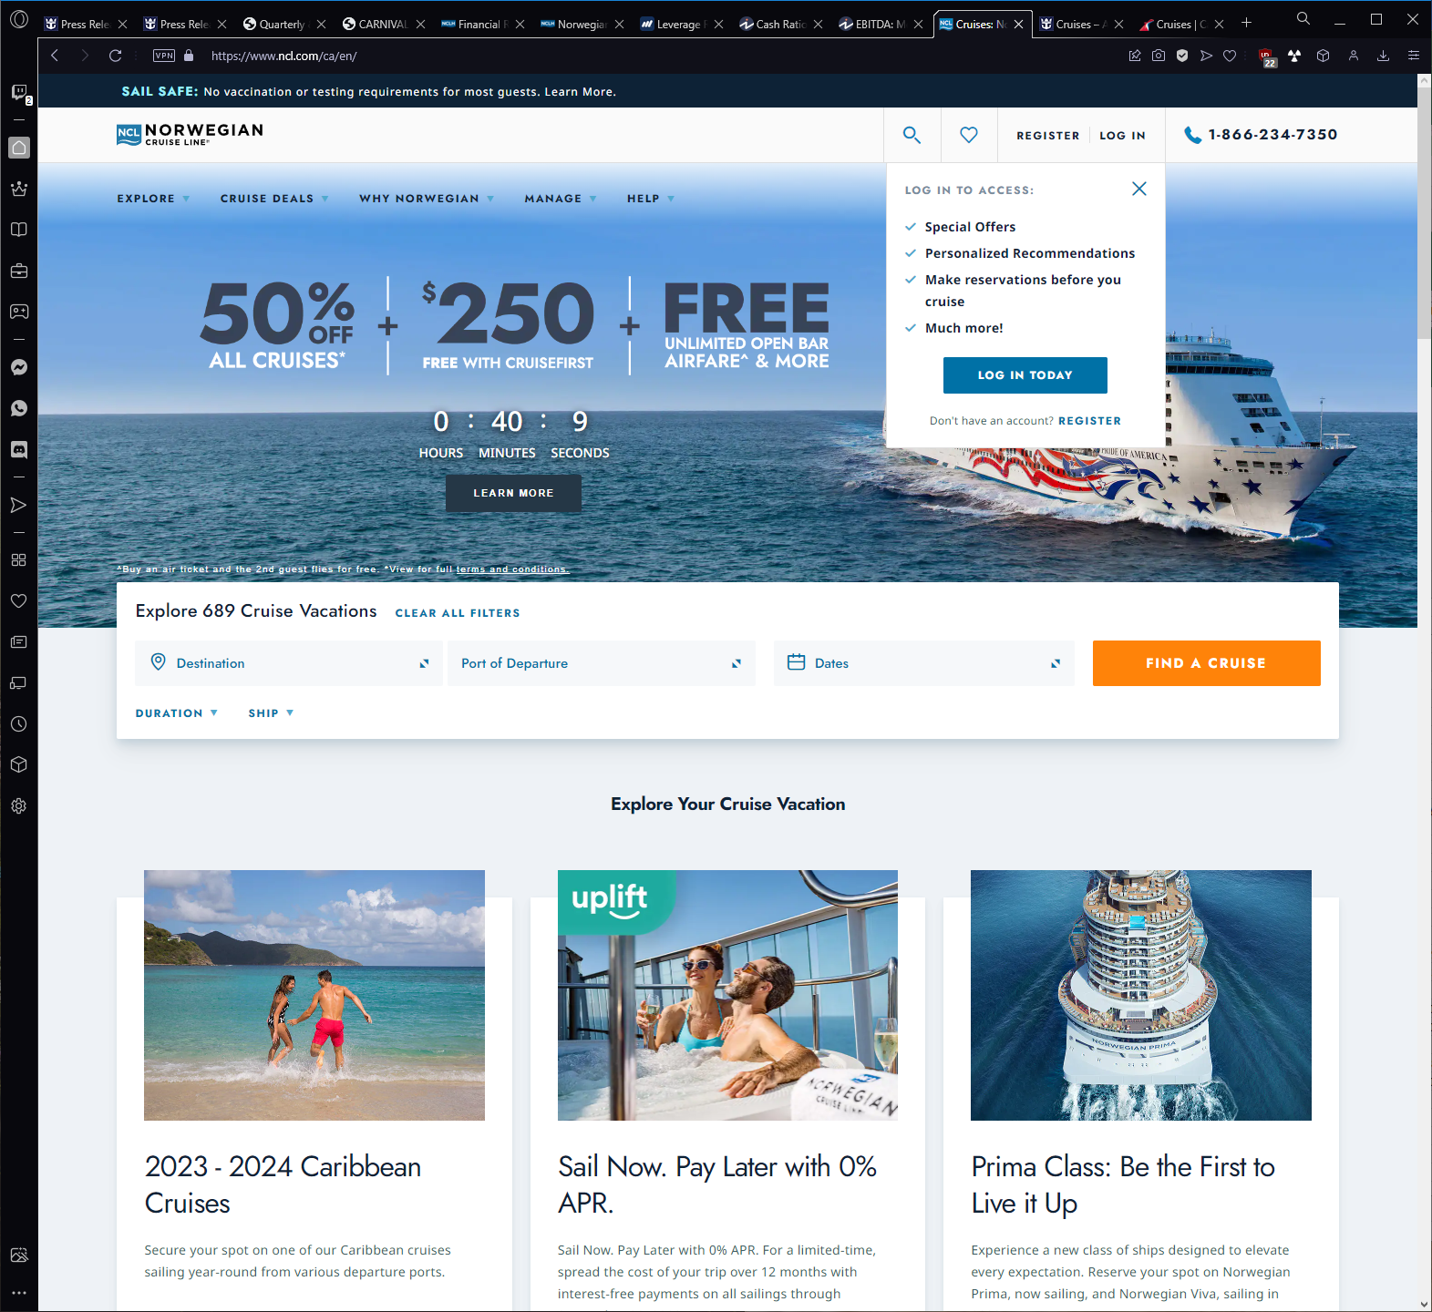



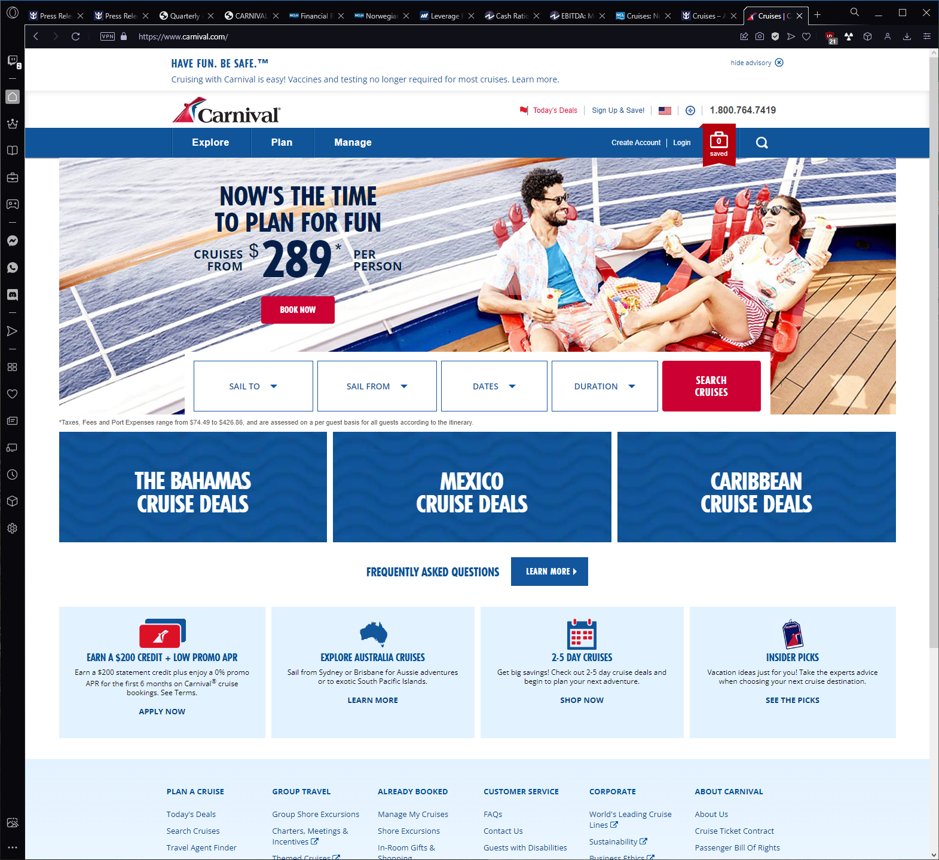

NCLH 2013

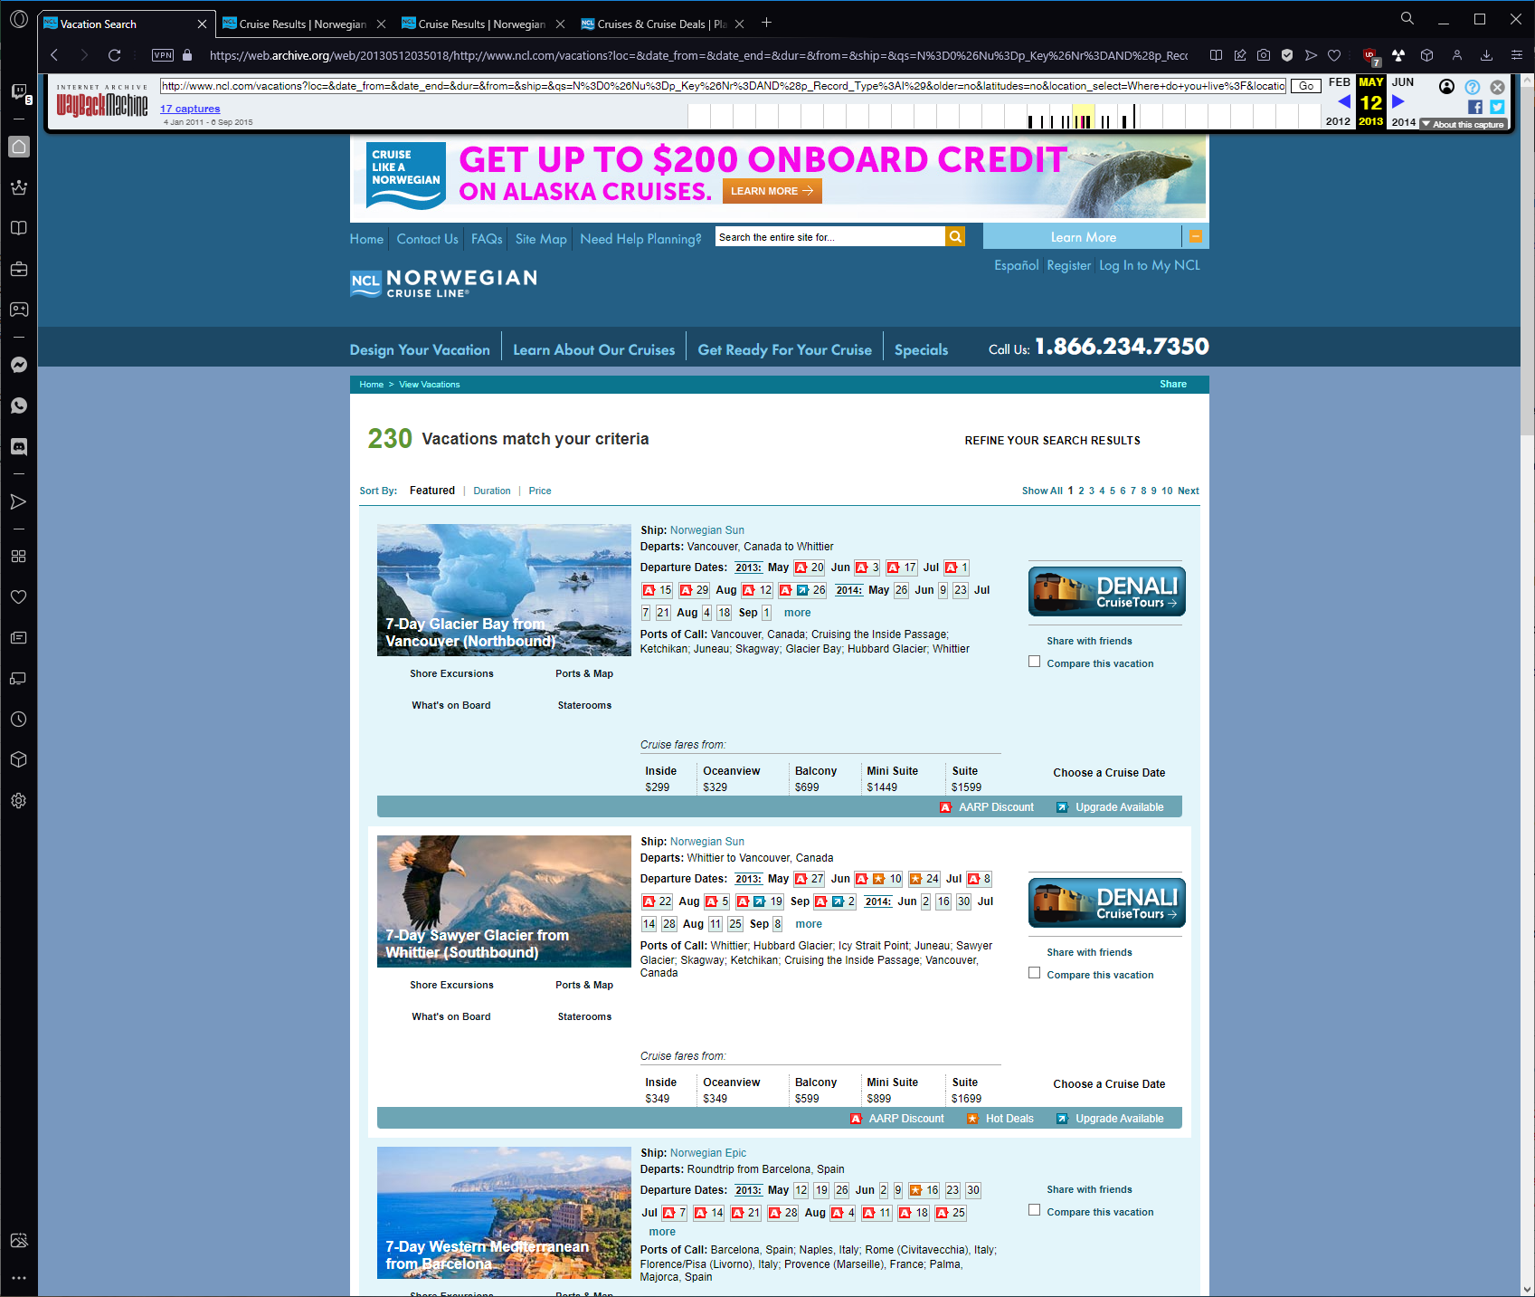

NCLH 2014

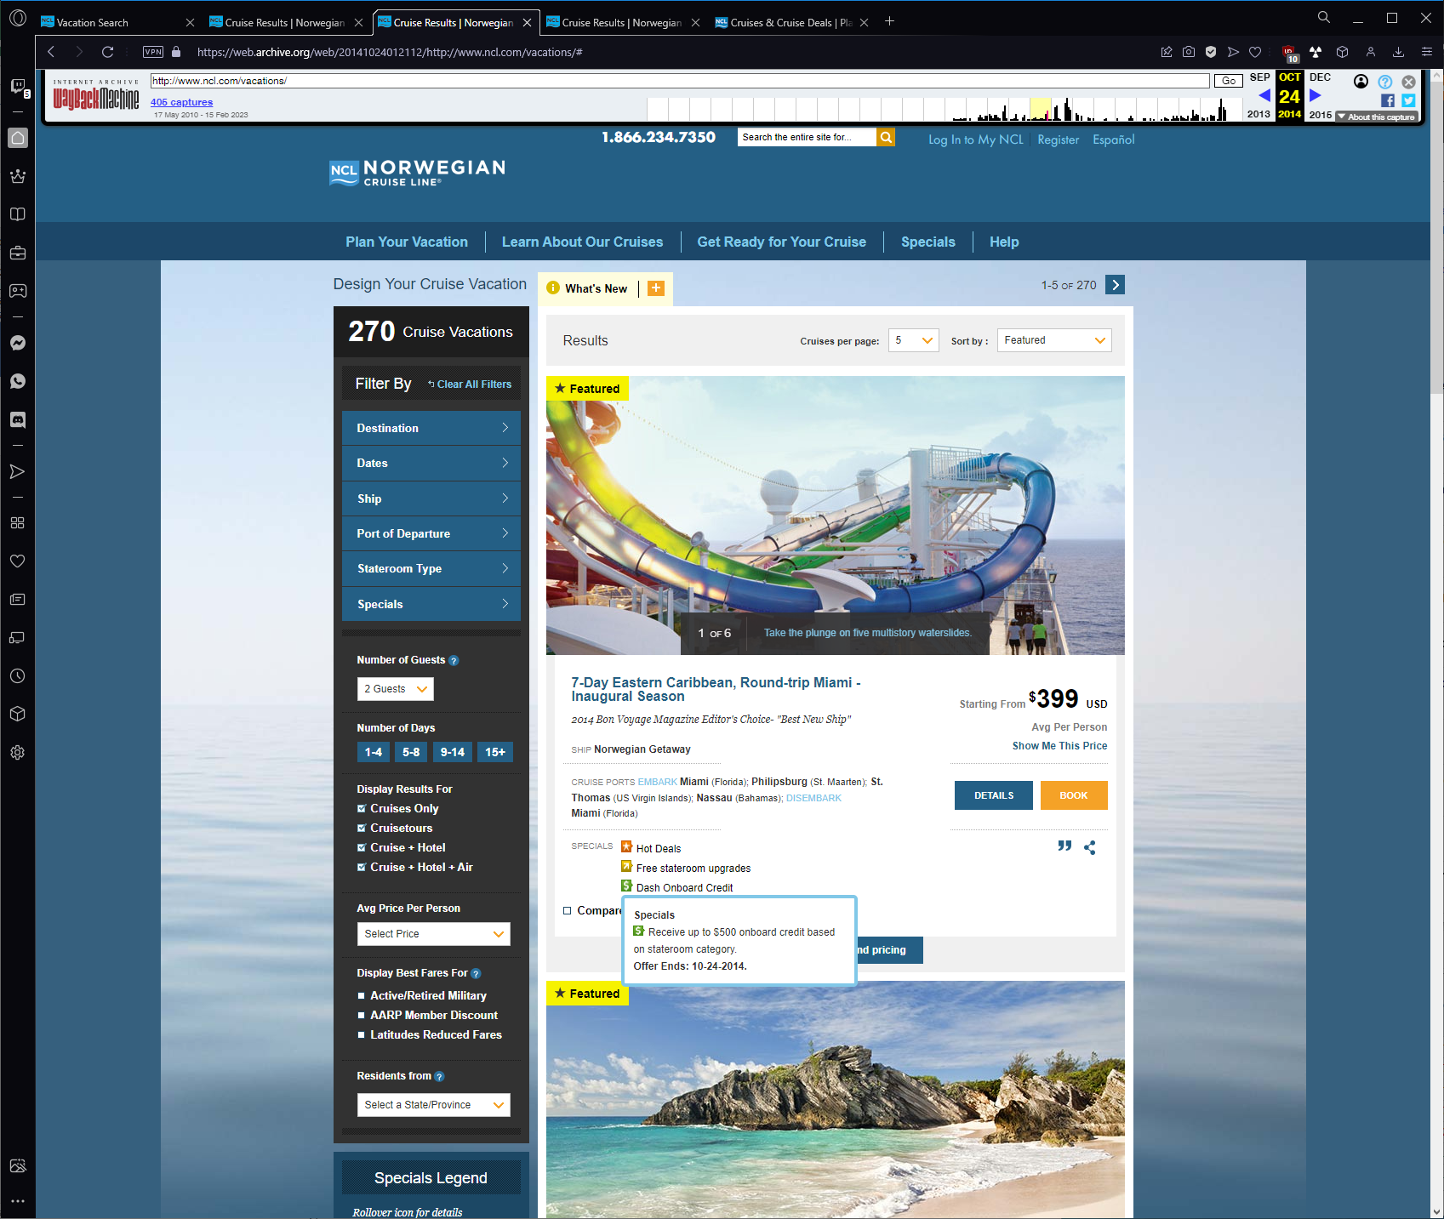

NCLH 2015

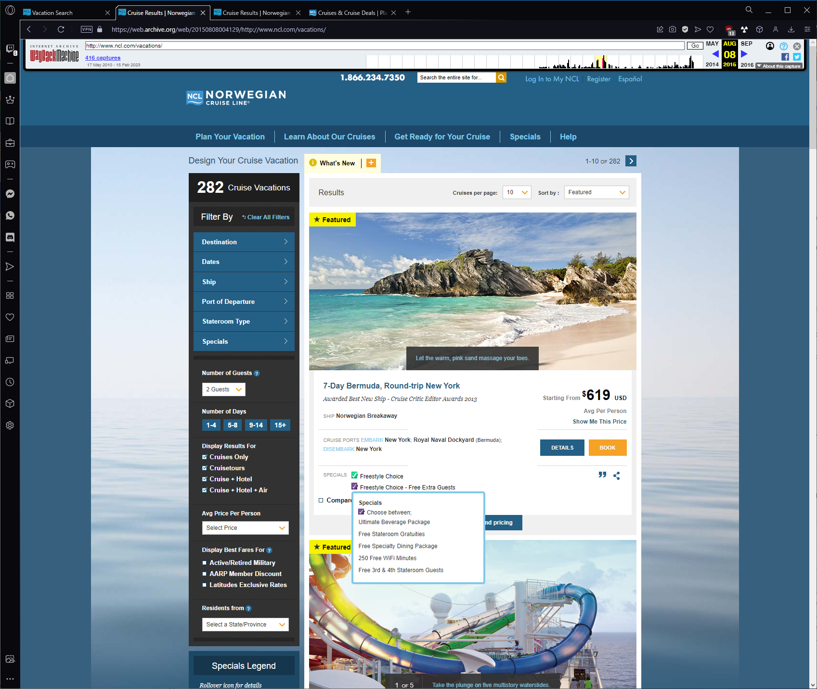

NCLH 2016

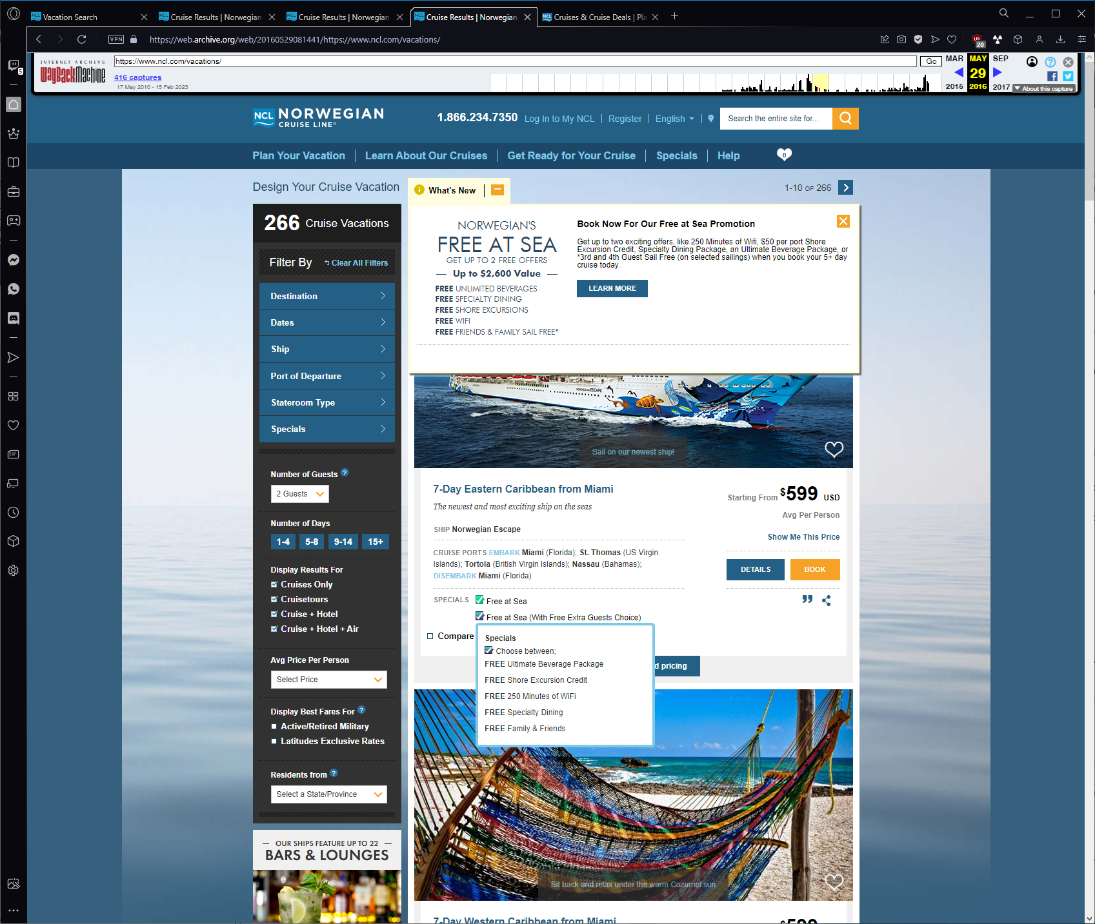

NCLH Today

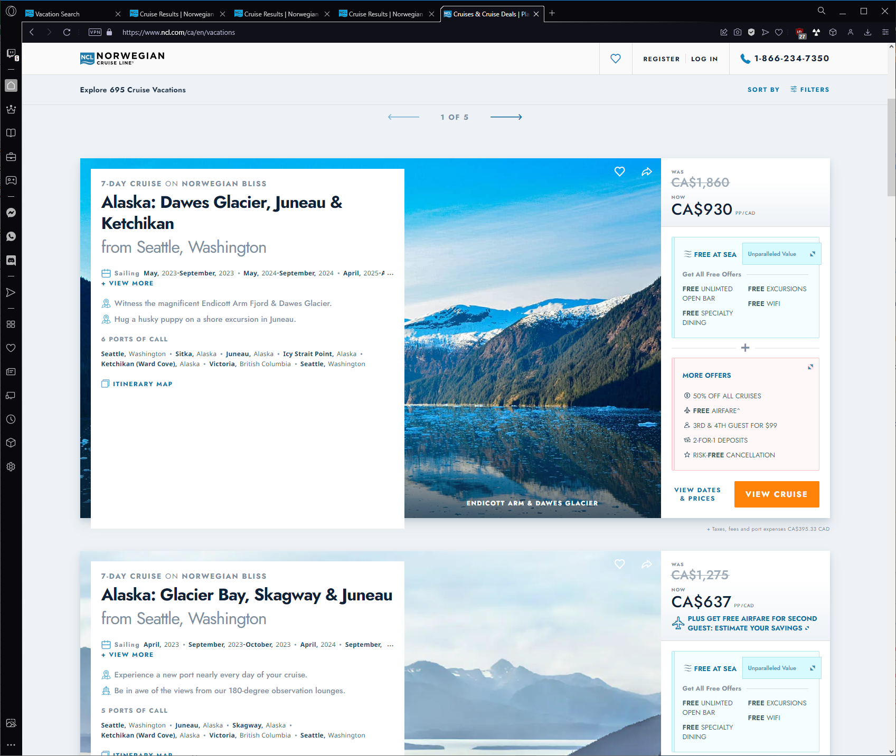

CCL Today

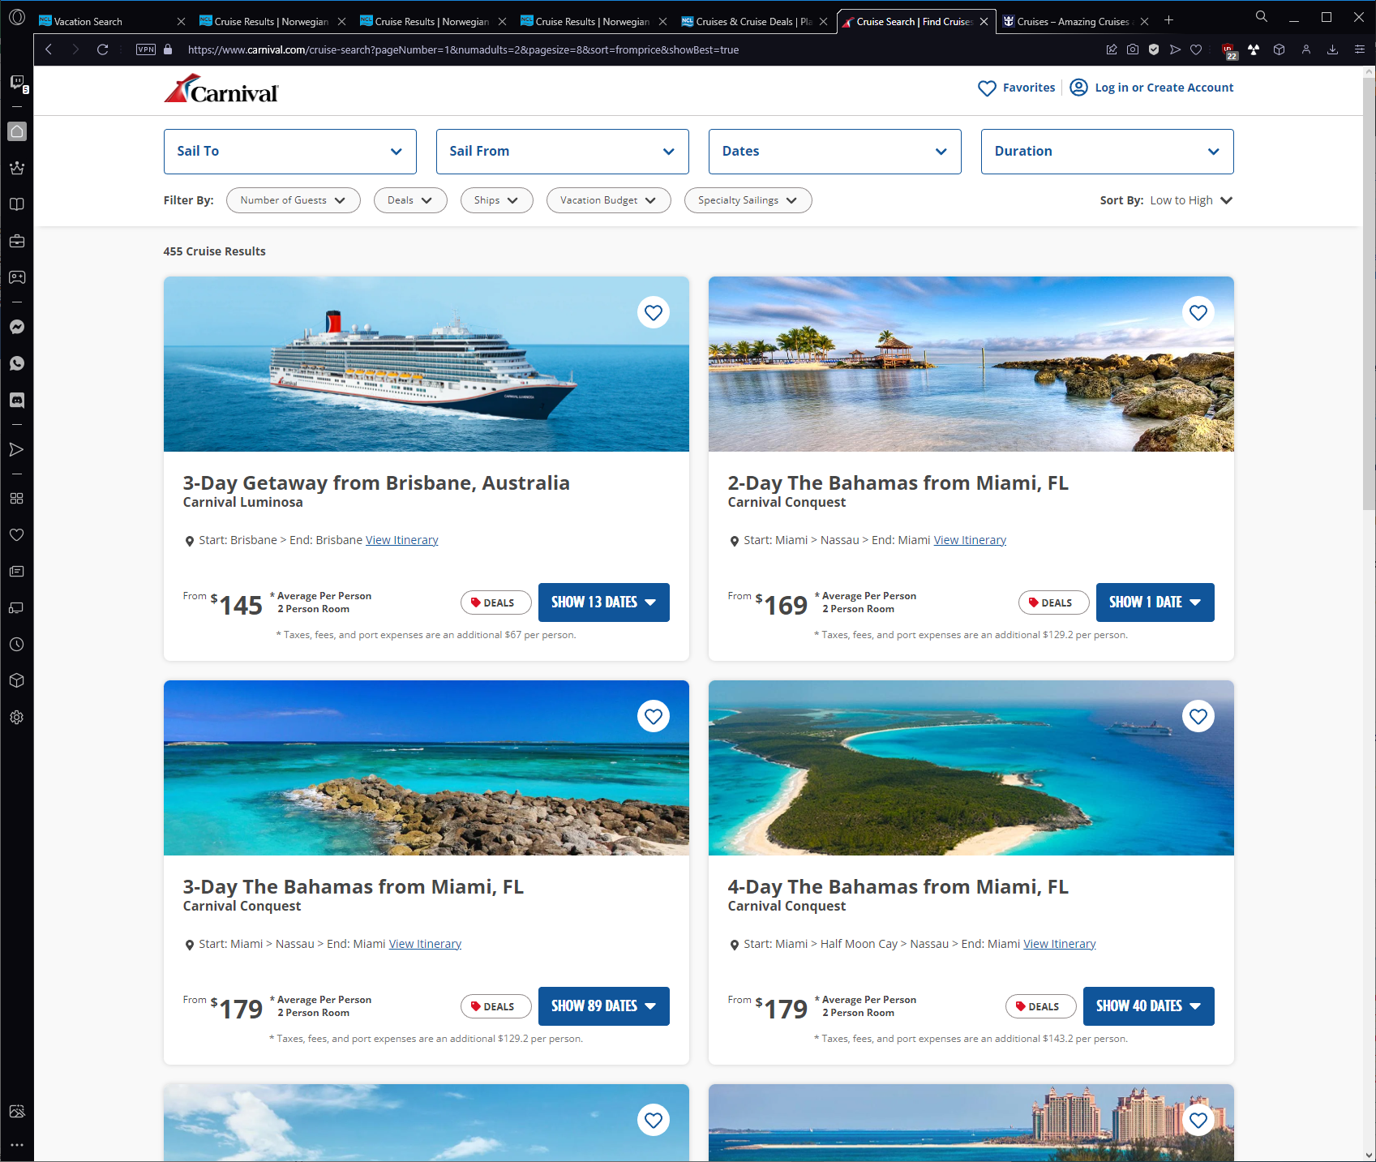

RCL Today

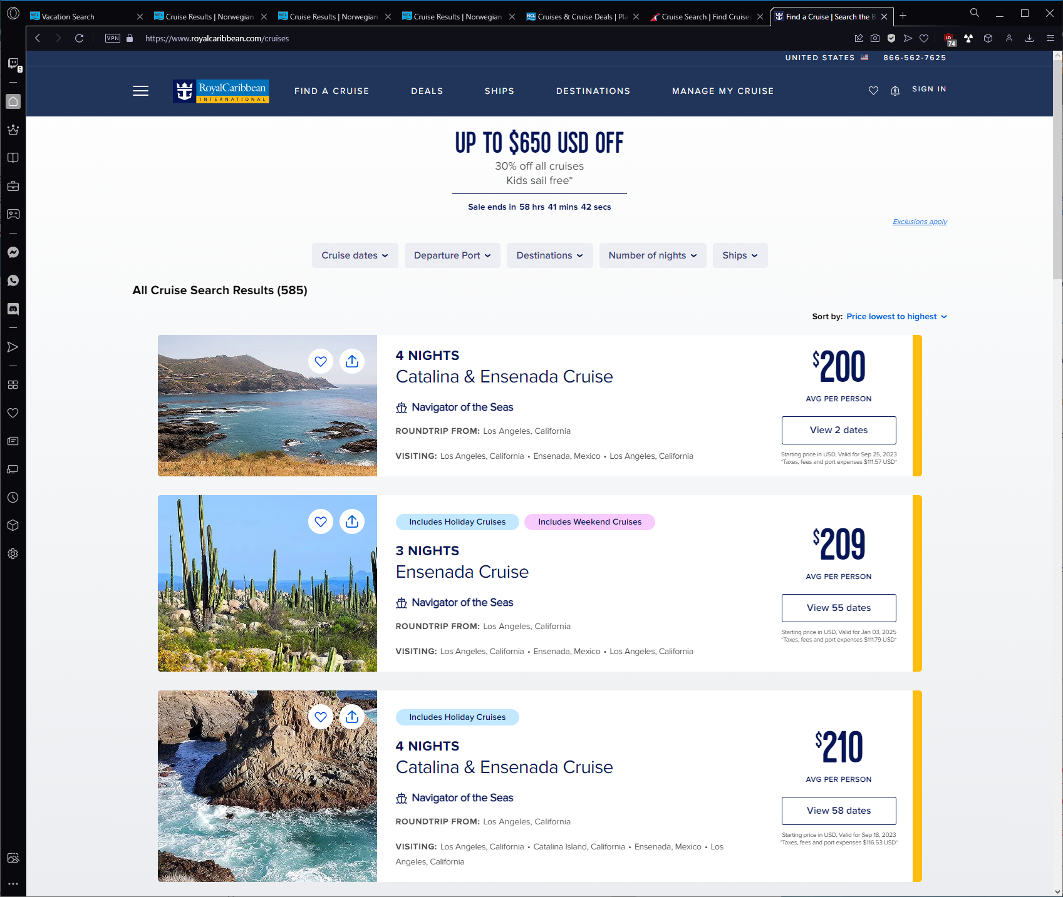

Search optimization

